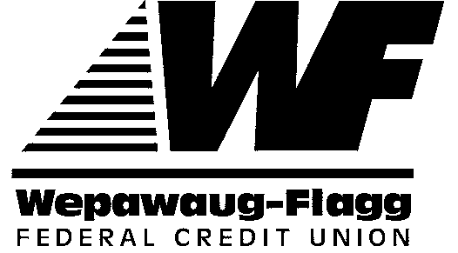

2017 Dennis Banks Memorial Scholarship Award Application

This award is open to all high school seniors, who will be full-time, degree seeking students enrolled at a U.S. accredited college or university or a current college freshman, sophomore or junior seeking a degree in business (accounting, finance, marketing, etc.) or a degree in education. Previous winners of this scholarship award, current employees and their family members are not eligible. Former employees are also not eligible. Applicants may apply for both scholarships provided they meet the requirements for each scholarship.

Applicants must either become a member or have at least one parent who is an existing member of the credit union. Applications must be received no later than Friday, May 19, 2017 at 5:00 pm to be considered. All the information submitted in this application is confidential and will be reviewed by a select committee appointed by the board of directors.

One applicant will be awarded with a check in the amount of $2,000.00. The check will be disbursed upon the credit union receiving a certificate of full-time enrollment from the college or university.

Student Application Requirements:
- Applicants will be required to provide a description of activities and/or contributions to their schools and community, along with a letter of confirmation and recommendation from a professional who headed one of those activities.
- Applicants will also be required to provide an essay of two to three pages on the following: “If you could meet one historical figure, who would it be and why? What would you ask them?”
- Applicants may use separate pages to answer each requirement.

Please mail applications to: Wepawaug-Flagg Federal Credit Union
Attn: Dennis Banks Scholarship Committee
105 Sanford St.
Hamden, CT 06514

- Please be sure to attach this page as a coversheet, along with a description of activities and/or contributions to your school and community, letter of confirmation and essay (three to four pages). Please direct any questions to Marketing Manager Michael Crutchfield at (203) 288-1695.
- All winners will be notified by Friday, June 23, 2017. A list of winners will be posted in each branch and on the website.

APPLICATION CHECKLIST:
School and Community contribution
Confirmation letter
Essay

2017 Dennis Banks Scholarship Application Form

PRINT OR TYPE — COMPLETE IN FULL

Applicant’s Name: _________________________ Phone # (Home/Cell):_________________

Social Security Number: ____________________ Date of Birth: _______________________

Address: _________________________________

City, State, ZIP: _____________________________________________________________

Method of Eligibility

Applicant’s Credit Union # (if applicable): _____________________
OR
Parents Credit Union #: ______________________ Parent’s Name: ___________________

(For High School Students): I will graduate from ____________________ in ________, 2017 to
(Name of High School)
pursue a degree in: _____________________.

(For all applicants): List below the college or university you are currently enrolled or will be enrolled at and your major:

Institution’s Name: ____________________________________________________

Address: _____________________________________________________________

_____________________________________________________________

Major: ______________________________

I hereby certify the previous information is accurate and complete. If I receive the scholarship, I give Wepawaug-Flagg Federal Credit Union permission to use my name and photograph in credit union newsletters, press releases, posters and on WFFCU’s website.

______________________________________________________________________________
Signature of Applicant Date

______________________________________________________________________________
Signature of Parent or Guardian Date
(If applicant is under age 18)

